Book Collection Management System

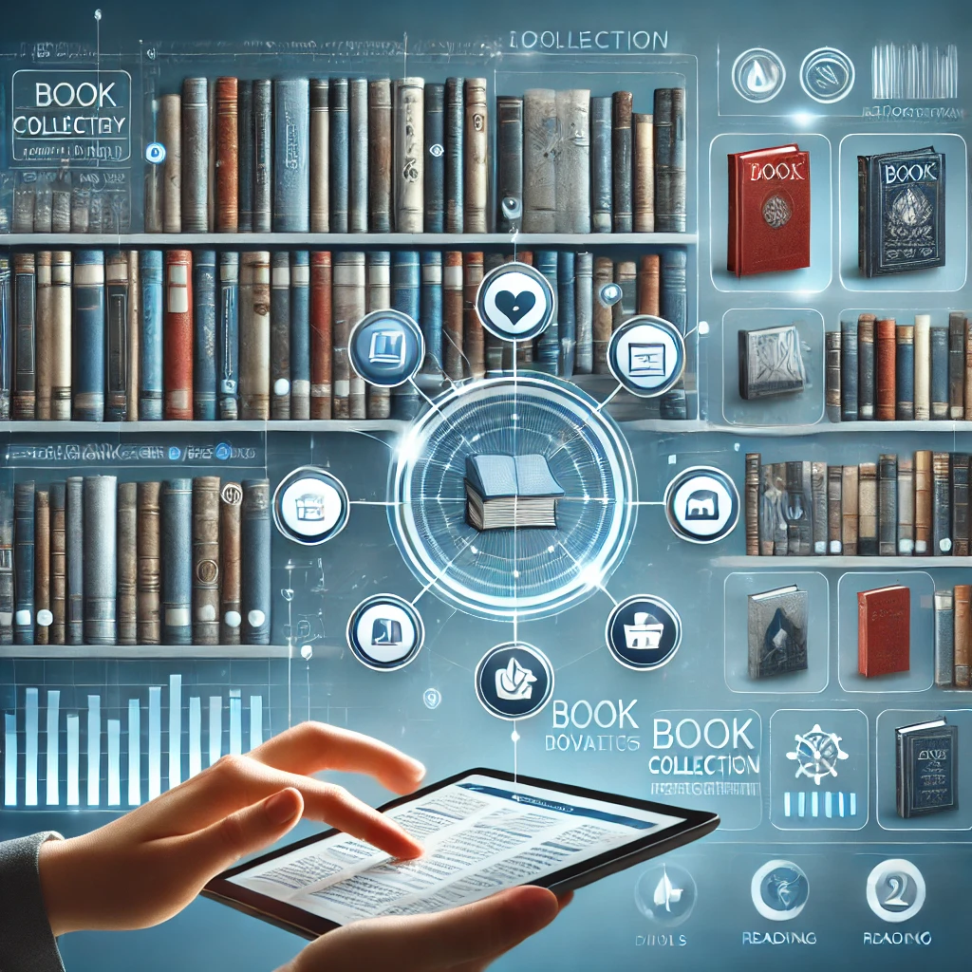

Contents

3

Team Members & Their Contributions: 3

Introduction, System Overview & System Idea Summary 4

What Information Will the System Offer the User? 5

What Data Will Be Stored by the System? 6

Attributes 7

Where will we get this data? 9

Use Cases 9

Target Users 10

Comparable Systems & Differentiation 11

HOW ITS UNIQUE? AND ITS ASPECT? 12

Problem Domain Sketch 13

References 14

# Team Members & Their Contributions:

**Bhanu:**

- Introduction and System Overview

- System Idea Summary

- Problem Domain Sketch

- Attributes

- References

- Photos

**Jaspreet:**

- What Information Will the System Offer the User?

- What Data Will Be Stored by the System?

**Sahib:**

- Where will we get this data?

- Use Cases

**Mandeep:**

- Target Users

- Comparable Systems & Differentiation

# Introduction, System Overview & System Idea Summary

Our project is a **Personal** Book Collection Management System (BCMS), and its main aim will be to help bibliophiles organize their libraries efficiently. The majority of enthusiastic readers accumulate big libraries, and the issue of how to sort and organize the numerous books can be acute. To fulfil this need, the BCMS was built having several key features;  
  
These include:  
  
- Adding Books: Users can book a new book to their library by keying in the details of the book or by using an ISBN barcode scanner on the book. This opens up the easy compilation of an entire personal library.  
  
- Reading Progress Tracking: The system shows books that are being read at that given time and the extent to which the user has read; features include the number of pages of the book the user has read.  
  
- Loaning and Borrowing: Borrower and lender aspect – it allows users to track books that one has loaned to friends or those that one borrowed from friends with dates and periods of loan.  
  
- Personalized Book Recommendations: According to the books that a user have read, as well as when entering the preferences, BCMS offers the user to read those books that can potentially interest the user.  
  
- Book Collection Insights: Due to the presented system, a user is aware of the books at his disposal and his or her reading preferences, which can help decide on what to read in the future and look through the previous literature.  
  
BCMS was envisaged to be the perfect solution to the management of personal book collections with as little fuss as can be imagined. Anything that gives its user satisfaction in reading and a desire to preserve the order amongst books is highly valuable with this system in place.

# 

# What Information Will the System Offer the User?

The BCMS will give users this information: According to the developed BCMS, users will obtain the following information:

1. Book Details: The readers shall be able to see such details for each book in the collection as title, author, publisher, picture, price, rating, reediness etc. It entails the title of the book, the author, type of the books, year of publication, ISBN number, description of the book and the image of the cover page. Through this feature, the users can easily go to the relevant information concerning the books in a short time.

2. Reading Progress: The system will also show how each book is being taken at the given time like not started, in progress and done. It also let the users indicate the progress of reading the book through a bar at the bottom of the page. This feature allows the users, to monitor and moderate their reading activity.

3. Loan Management: Users of BCMS will have books which they have lent to friends or those which they borrowed from friends. It will also include such particular features as dates of the loan and dates when the material is due. Of particular important is the fact that the app helps the users in organizing their borrowed books and even when they are supposed to return them.

4. Recommendations: Recommendations of new books With the list of the books the user has read, as well as his/her interests the system will suggest the books to read. One of the most notable aspects of this application is the book recommender system that would suggest to the user the kind of book he/she would like in the light of the books that the user has read.

5. Collection Statistics: Thus, users can see the overall number of books in the library, belonging to what genres and, therefore, their preferences in reading. It also helps the users to make sense of their library, and to find out how they read and therefore which pattern fits them best.

# 

# What Data Will Be Stored by the System?

The BCMS will store several types of data to work well: There will be several kinds of data that should be placed in the BCMS in order that the BCMS will function properly:

1. User Data: Such data are for instance the user’s name, the email which the user create and form a password to log into the application. This

The data is needed for creating the account and for Account Management and for security of the data.

2. Book Data: The system will include registers for each of them containing the name of the book, title, the author, category, date of issue, number, a short description, an illustration of the cover and the publishing house. This is beneficial to the users in the sense that they receive all the information concerning the books.

3. Reading Progress Data: This comprises of the current status of each book; whether it is new, current, or completed; and the percentage to which it is read. It can therefore be employed to keep track of, and facilitate the regulation of, the process of reading.

4. Loan Data: The records of the loans and/or borrowings and more so the records which bear names of the borrowers or lenders as well as the date/s on which the borrower/lender loaned/borrowed is also going to be stored in the system. This Assist in managing book loans proper.

5. Recommendation Data: After that, the system will begin to make a record of his reading history, as well as other tendencies, and thus, only those publications, which will be interesting for the reader, will be offered to him. From this data, people can be advised on the books they might like to read by their patterns of consumption.

6. Collection Statistics: This information will be collected to make use of it in making beautiful statistics and reports concerning of the books a certain user has read and those he or she is reading at the time being. This is important especially when attempting to have some notion of the assembled collection and the emerging trends which are visible.

# 

# Attributes

**1. User Data**

**•** UserID (Integer)

• UserName (String)

• Email (String)

• Password (String)

**2. Book Data**

**•** BookID (Integer)

• Title (String)

• Author (String)

• Category (String)

• DateOfIssue (Date)

• ISBN (String)

• Description (String)

• CoverImage (Binary)

• Publisher (String)

**3. Reading Progress Data**

**•** ReadingID (Integer)

• BookID (Integer)

• UserID (Integer)

• Status (Enum: They include New, In Progress and Completed.

• Progress (Float)

**4. Loan Data**

**•** LoanID (Integer)

• BookID (Integer)

• BorrowerID (Integer)

• LoanDate (Date)

• DueDate (Date)

• ReturnDate (Date)

**5. Recommendation Data (Generated Dynamically):**

**•** Derived Attributes:

• UserID (Integer)

• BookID (Integer)

• Genres (String, Array)

• Ratings (Float)

• Generated By: To suggest books, readng history, genre and ratings would be analyzed.

**6. Collection Statistics (Generated Dynamically):**

**•** Derived Attributes:

• TotalBooksRead (Integer)

• CurrentlyReading (Integer)

• ReadingTrends (String, Array)

• Generated By: Accomplishing totals and trends from the existent reading progress as well as user data.

# Where will we get this data?

The BCMS will get data from various things:

Firstly, it's USER INPUT as users can type details about their books and reading progress. Nowadays people are very healthy in using ONLINE DATABASES they work with public APIs (Application Programming Interfaces) like Google Books API, and Open Library API to fetch their book Data. We can also generate system data based on user actions related to reading progress, loan management, feedback, and collection statistics. However for the testing purposes we are going to use dummy data.

# Use Cases

1. Add Book: It is easy to add books; one can enter a book detail or enter the ISBN(International Standard Book Number).

2. Edit Book Details: Users can modify details related to books available with them.

3. Delete Book: Users can remove books from their collection.

4. Track Reading Progress: The reading status and the current progress or statistics of the books being read can be modified by the users.

5. Loan Management: Users can document information of books that have been loaned out to or borrowed from friends.

6. View Book Collection: Its features include the ability to browse and search at the list of all books a user has.

7. Receive Recommendations: Users can get personalized book suggestions.

8. Generate Collection Statistics: Users are able to view the information related to the books and their reading behavior.

# Target Users

Who uses a book management system? Well, there are a few different groups:

1. Book Lovers: Those who compile their own personal libraries and have considerable book collections which they wish to sort and catalog.

2. Avid Readers: Readers who wish to monitor the number of books they’ve read and get new books suggestions.

3. Students and Researchers: Anyone that needs to sort, archive or categorize academic or research books that they have.

 4. Little Librarians: People like a small book collection loaner who require to monitor books on loan and how frequently the books are borrowed. BCMS has provisions for loaning management and for organizing books.

 Each of these groups has their own needs and things they need the system to do. The design of the system should make it easy for everyone to do their job and keep the library running smoothly.



# Comparable Systems & Differentiation

# Goodreads: A site that can help the users to monitor books, read reviews on them, and get suggestions on new books. Instead it is more of a ‘social’ platform and lacks good loan management tools.

(Goodreads, n.d.)

# LibraryThing: A site for listing books and to meet an expectant bookworm or a book enthusiast. It has several attractive qualities but often requires effort in operation and, therefore, is not very simple.

(LibraryThing, n.d.)

# Book Collector (by Collectorz. com): Software for listing books with many attributes. But it requires a monthly paid subscription and is rather inconvenient on a phone

(Collectorz, n.d.)



# HOW ITS UNIQUE? AND ITS ASPECT?

The Book Collection Management System (BCMS) is mainly personal with several features customized for the book collection enthusiasts. Unlike generic systems, BCMS provides:

* **Personalized Experience**: Help in the recommendation of books tailored to the reader as well as offering deeper meaning for books read.
* **User-Friendly Interface**: Go to for anyone whether you understand programming or not it will be fairly easy to use.
* **Scalability**: It can expand equally well with any size of the collection you have.  
  Integration: Easily fetches information about all books from online databases.
* **Data Security**: It is your own property: you remain the owner of the data and its preservation remains under your control, which also implies confidentiality.

BCMS is like having a virtual assistant for books so that clients can make the most of their reading collection.

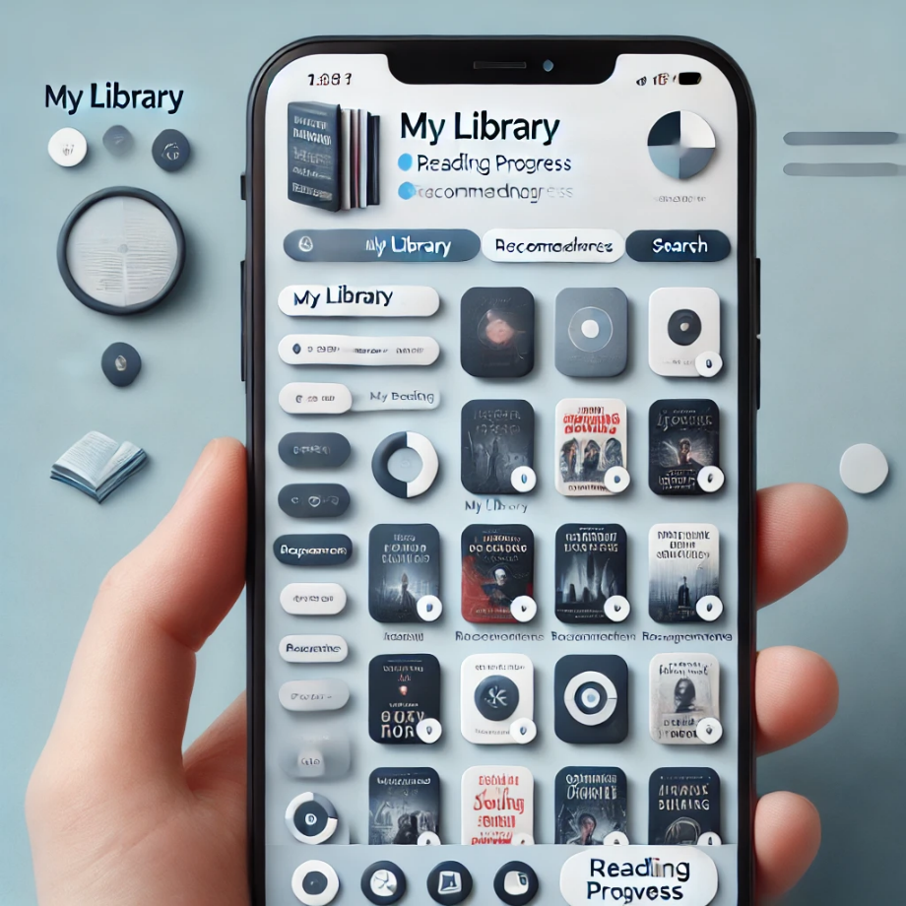

# Problem Domain Sketch

The BCMS connects users with book, loan management, and recommendation systems.

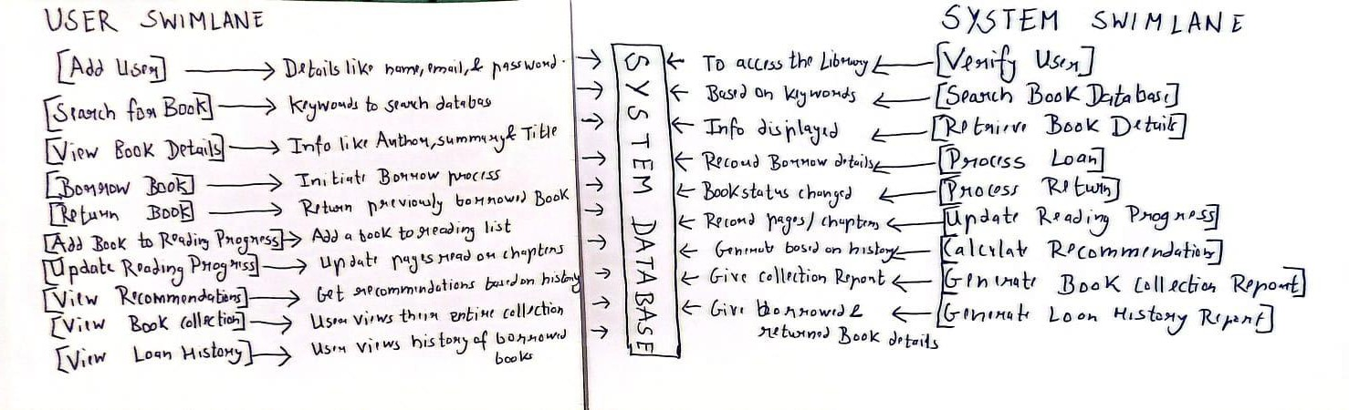

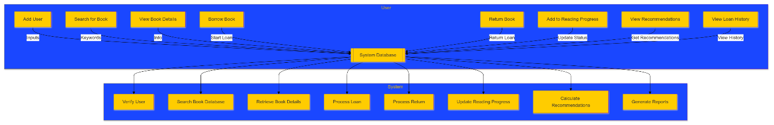

# References

*Collectorz*. (n.d.). Retrieved from Collectorz: https://www.collectorz.com/book

*Goodreads*. (n.d.). Retrieved from Wikipedia: https://en.wikipedia.org/wiki/Goodreads

*LibraryThing*. (n.d.). Retrieved from Wikipedia: https://en.wikipedia.org/wiki/LibraryThing